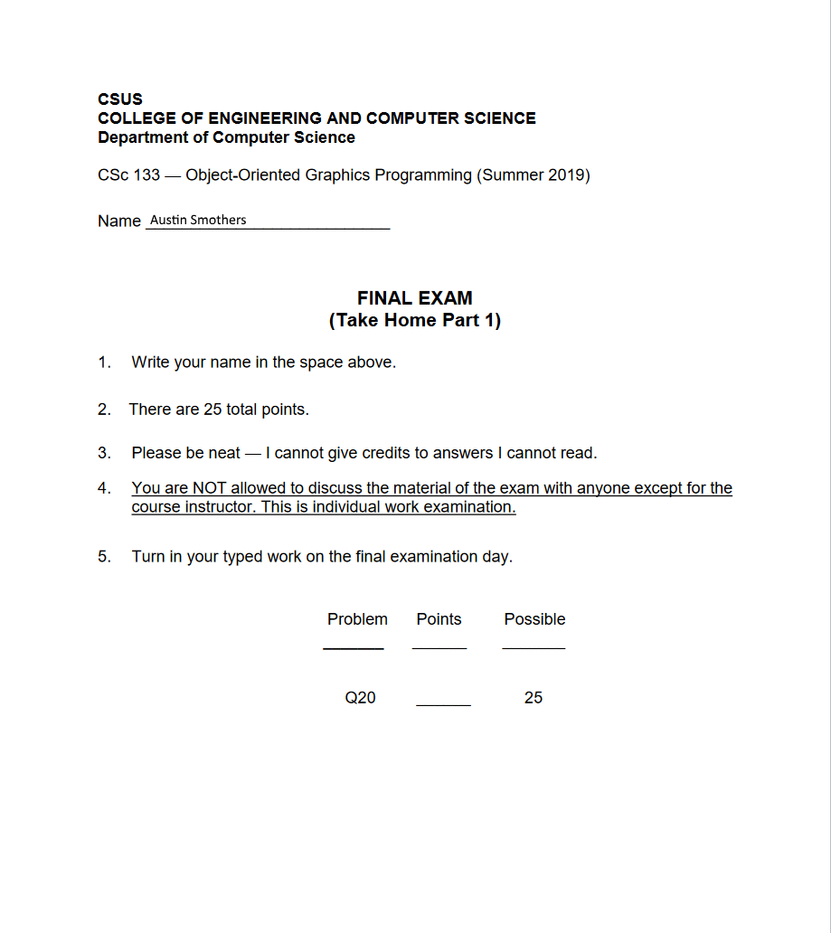



* 1. Affine transformation is a way of mapping that preserves points, straight lines, and planes.
  2. After an affine transformation, finite points must remain finite, and parallel lines must remain parallel.

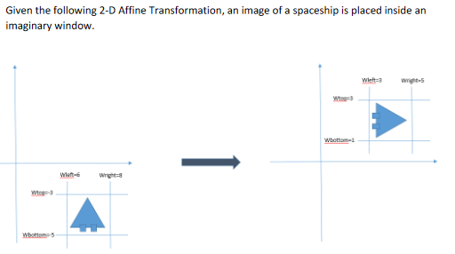

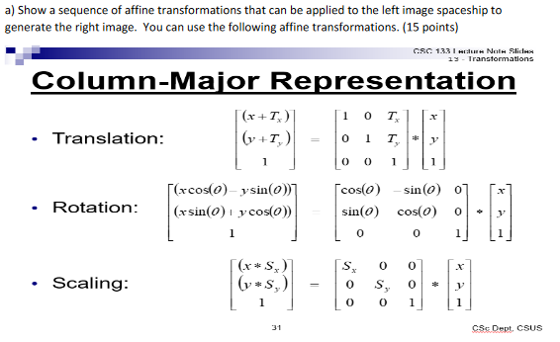

**Translate: x-3, y+6 🡪 Translateorigin: x-3, y-1 🡪 Rotate: 900 🡪 Translateback: x+3, y+1**

|  |  |  |  |  |  |  |  |  |  |  |  |  |  |  |
| --- | --- | --- | --- | --- | --- | --- | --- | --- | --- | --- | --- | --- | --- | --- |
| Translate | | |  |  |  |  |  | TranslateO | | |  |  |  |  |
| 1 | 0 | -3 | x | x | = | x-3 |  | 1 | 0 | -3 | x | x-3 | = | x-6 |
| 0 | 1 | 6 | y | y+6 | 0 | 1 | -1 | y+6 | y+5 |
| 0 | 0 | 1 | 1 | 1 | 0 | 0 | 1 | 1 | 1 |

|  |  |  |  |  |  |  |  |  |  |  |  |  |  |  |
| --- | --- | --- | --- | --- | --- | --- | --- | --- | --- | --- | --- | --- | --- | --- |
| Rotate | | |  |  |  |  |  | TranslateB | | |  |  |  | **Solution** |
| 0 | -1 | 0 | x | x-6 | = | -(y+5) |  | 1 | 0 | 3 | x | -(y+5) | = | **-(y+5)+3** |
| 1 | 0 | 0 | y+5 | (x-6) | 0 | 1 | 1 | (x-6) | **(x-6)+1** |
| 0 | 0 | 1 | 1 | 1 | 0 | 0 | 1 | 1 | **1** |



ComboMatrix = (((Translateback*Rotate)*Translateorigin­)*Translate)

|  |  |  |  |  |  |  |  |  |  |  |  |  |  |  |  |  |  |  |
| --- | --- | --- | --- | --- | --- | --- | --- | --- | --- | --- | --- | --- | --- | --- | --- | --- | --- | --- |
| TranslateB | | |  | Rotate | | |  | Combo1 | | |  | TranslateO | | |  | Combo2 | | |
| 1 | 0 | 3 | x | 0 | -1 | 0 | = | 0 | -1 | 3 | x | 1 | 0 | -3 | = | 0 | -1 | 4 |
| 0 | 1 | 1 | 1 | 0 | 0 | 1 | 0 | 1 | 0 | 1 | -1 | 1 | 0 | -2 |
| 0 | 0 | 1 | 0 | 0 | 1 | 0 | 0 | 1 | 0 | 0 | 1 | 0 | 0 | 1 |

|  |  |  |  |  |  |  |  |  |  |  |
| --- | --- | --- | --- | --- | --- | --- | --- | --- | --- | --- |
| Combo2 | | |  | Translate | | |  | **ComboFinal** | | |
| 0 | -1 | 4 | x | 1 | 0 | -3 | = | **0** | **-1** | **-2** |
| 1 | 0 | -2 | 0 | 1 | 6 | **1** | **0** | **-5** |
| 0 | 0 | 1 | 0 | 0 | 1 | **0** | **0** | **1** |